**MATLAB RECORD**

1. **Calculating limits**

**Aim:** Write a program to calculate  by using MATLAB

**Program:**

>> syms x

>> f=(x^2-25)/(x-5)

>> limits[f,5]

**Output:**

f=10

1. **Graphical Interpretation of a function with two variables**

**Aim:** Write a program to graphical interpretation of a function with two variables by using MATLAB.

**Program:**

>> [x,y]=meshgrid(-4:1:4,-4:1:4);

>> z = x.^3 + y.^3;

>> mesh(x,y,z)

**Output:**

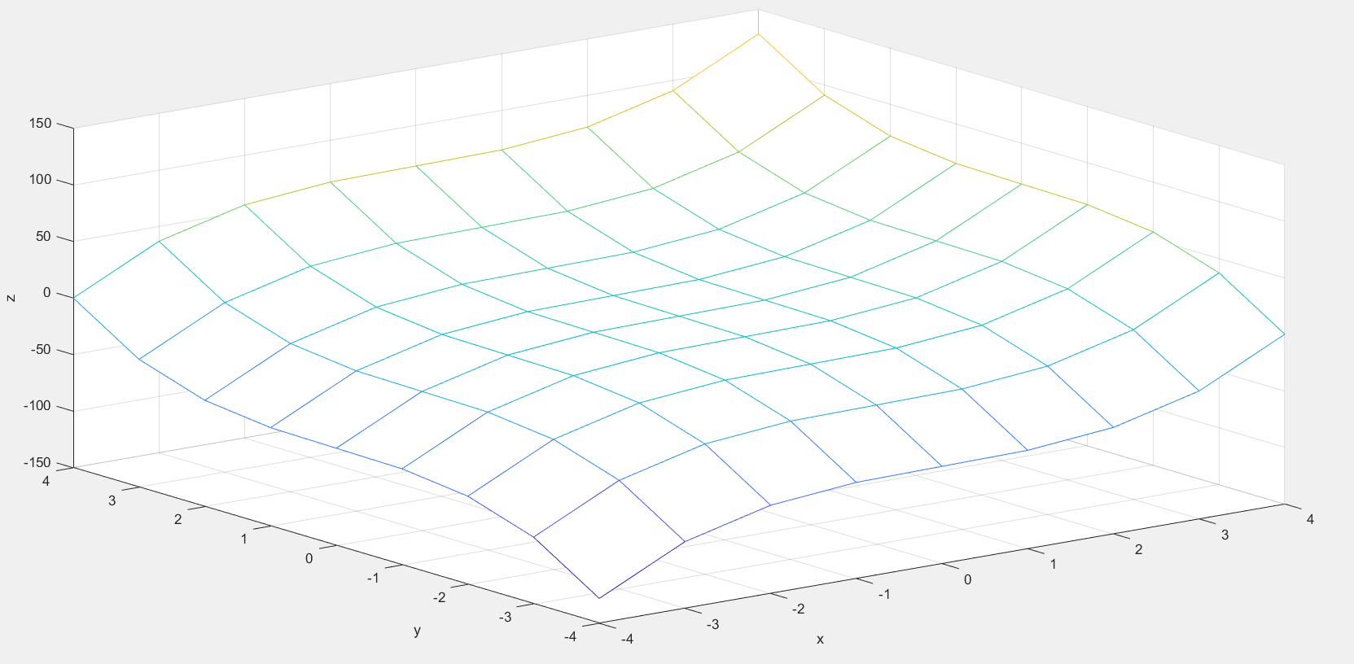

1. **Computing basic operations like addition, subtraction, multiplication, transpose, right division, left division in matrices**

**Aim:** Write a program to generate a matrix and perform some basic operation on matrices such as addition subtraction, multiplication, transpose, right division, left division by using MATLAB.

1. **Addition**

**Program:**

>> A=[1 7 5;7 2 8;9 6 4];

>> B=[9 5 4;8 4 6;9 0 6];

>> C=A+B

**Output:**

C =

10 12 9

15 6 14

18 6 10

1. **Subtraction:**

**Program:**

>> A=[1 7 5;7 2 8;9 6 4];

>> B=[9 5 4;8 4 6;9 0 6];

>> D=A-B

**Output:**

D =

-8 2 1

-1 -2 2

0 6 -2

1. **Multiplication:**

**Program:**

>> A=[1 7 5;7 2 8;9 6 4];

>> B=[9 5 4;8 4 6;9 0 6];

>> E=A*B

**Output:**

E =

110 33 76

151 43 88

165 69 96

1. **Transpose:**

**Program:**

>> A=[1 7 5;7 2 8;9 6 4];

>> F=A'

**Output:**

F =

1 7 9

7 2 6

5 8 4

1. **Right Division:**

**Program:**

>> A=[1 7 5;7 2 8;9 6 4];

>> B=[9 5 4;8 4 6;9 0 6];

>> G=A/B

**Output:**

G =

0.5258 -0.2784 0.4845

0.2371 1.1392 -0.2423

-0.4227 0.6649 0.9536

**f) Left division:**

**Program:**

>> A=[1 7 5;7 2 8;3 4 5];

>> B=[4 5 7;3 4 7;9 5 7];

>> H=A\B

**Output:**

H =

25.5455 5.4545 5.7273

15.3636 3.6364 3.8182

-25.8182 -5.1818 -5.0909

**4. Computing matrix powers**

**Aim:** Write a program to compute the power of a square matrix by using MATLAB.

**Program:**

>> A=[1 7 5;7 2 8;9 6 4];

>> H=A^2

**Output:**

H =

95 51 81

93 101 83

1. 99 109

**5.Plotting three dimensional surfaces.**

**Aim:** Write a program to plotting three dimensional surfaces

By using MATLAB.

**Program:**

>> x=-3:0.1:3;

>> y=x;

>> [x1,y1]=meshgrid(x,y);

>> z1 = x1.^2+y1.^2;

>> surf(x1,y1,z1)

**Output:**

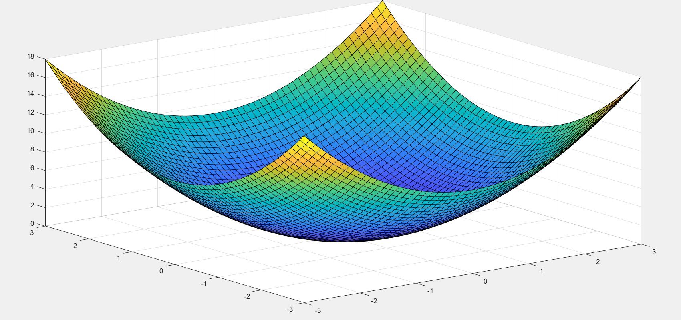

**6. Finding Union, Intersection, Difference in set theory**

**Aim:** Write a program to compute the union, intersection, difference in set theory by using MATLAB.

**Program:**

1. **Intersection:**

>> A=[7 1 7 7 4 3];

>> B=[2 4 7 0 2 7];

>> C=intersect(A,B)

**Output:**

C =

4 7

1. **Union:**

>> A=[7 1 7 7 4 3];

>> B=[2 4 7 0 2 7];

>> D=union(A,B)

**Output:**

D =

0 1 2 3 4 7

**c) Difference:**

>> A=[7 1 7 7 4 3];

>> B=[2 4 7 0 2 7];

>> C=setdiff(A,B)

**Output:**

C =

1 3

**7. Extract sub matrix from given matrix.**

**Aim:** Write a program to Extract sub matrix from given matrix by using MATLAB.

**Program:**

>> M=[1 2 3; 4 5 6; 7 8 9];

>> M([1:2],[2:3])

**Output:**

ans =

2 3

5 6

**8. Specify a given matrix into matlab workspace**

**Aim:** Write a program to Specify a given matrix into matlab workspace

**Program:**

>> M=[1 2 3; 4 5 6; 7 8 9]

**Output:**

M =

1 2 3

4 5 6

7 8 9

**9. Basic statements of two dimensional graphs representation.**

**Aim:** Write a program to two dimensional graph y=x by using MATLAB.

**Program:**

>> x=0:1:10;

>> y=x;

>> plot(x,y)

**Output:**

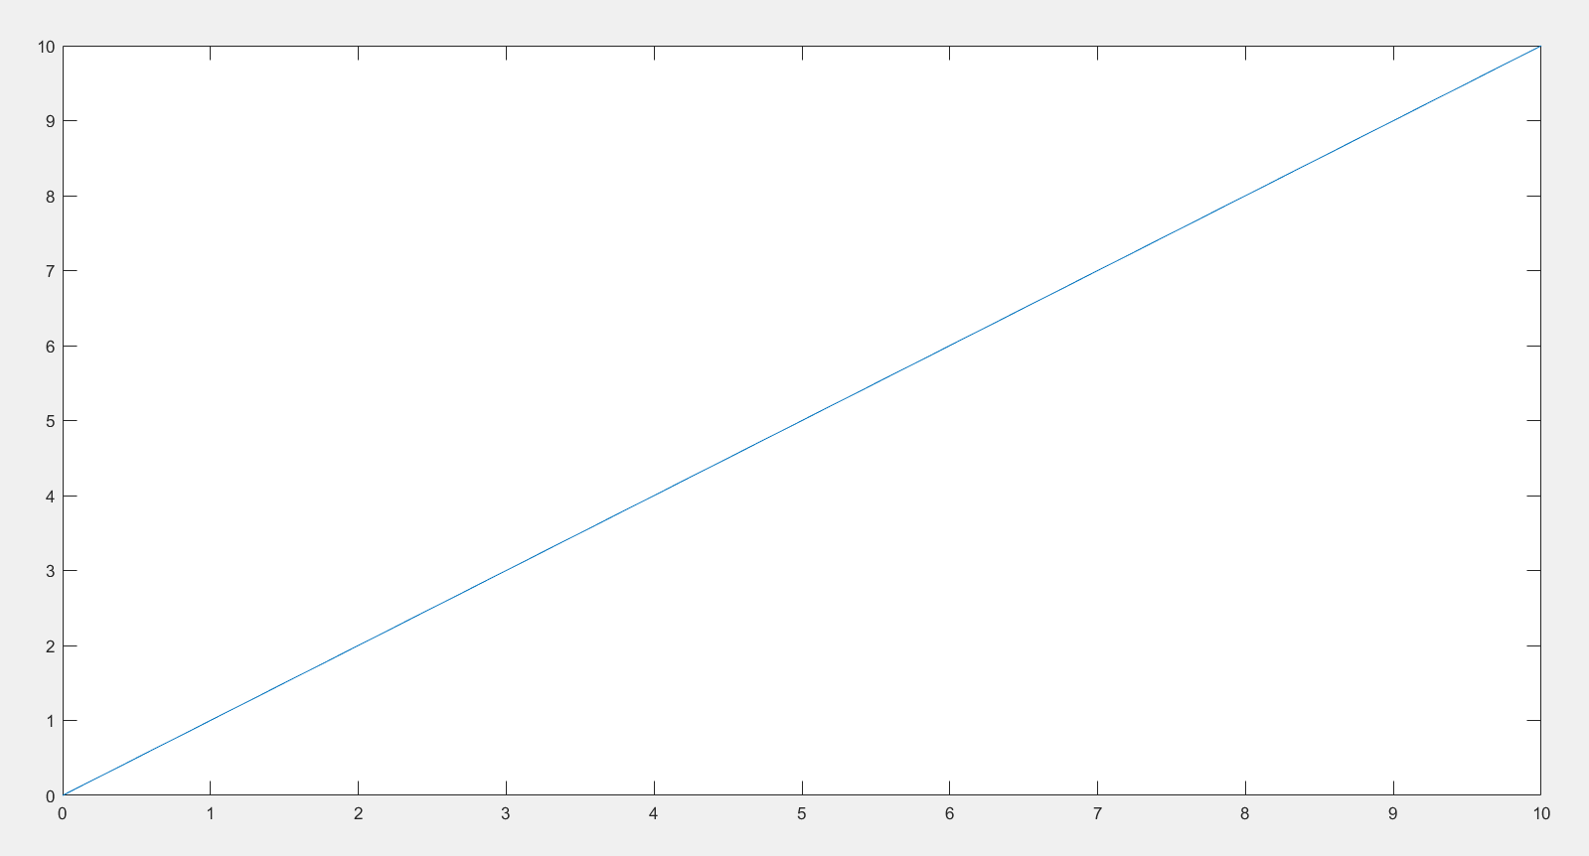

**10. Entering a given complex matrix into matlab workspace.**

**Aim:** Write a program to a given complex matrix into MATLAB.

**Program:**

>> A=[1 + 2i, 3 - 4i; -5 + 6i, 7 + 8i];

>> disp(A)

**Output:**

1.0000 + 2.0000i 3.0000 - 4.0000i

-5.0000 + 6.0000i 7.0000 + 8.0000i

**11. Formatting a two dimensional plots by using MATLAB.**

**Aim:** Write a program to plot  and  by using MATLAB

**Program:**

>> x=0:1:10;

>> y1 = x;

>> y2 = x.^2;

>> plot(x, y1, 'b--', 'linewidth', 2);

>> hold on;

>> plot(x, y2, 'r-o', 'linewidth', 1.5);

**Output:**

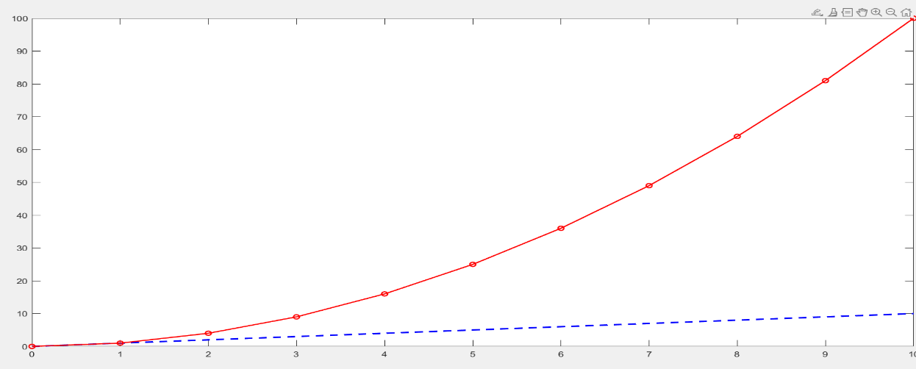

**12. Finding the indefinite integrals**

**Aim:** Write a program to find the integration of  by using MATLAB.

**Program:**

>> syms x;

>> f = x^2;

>> F = int(f, x);

>> disp(F);

**Output:**

x^3/3

**13.** **Finding the definite integrals**

**Aim:** Write a program to find the  by using MATLAB.

**Program:**

>> syms x;

>> f = x^2;

>> F = int(f, x, 1, 3);

>> disp(F);

**Output:**

26/3

**14. Arithmetic operations with scalars**

**Aim:** Write a program to add scalars, subtraction, multiplication, Right division, left division, Exponentiation.

**Program:**

1. **Addition**

>> a = 5;

>> b = 3;

>> result = a + b;

>> disp(result);

**Output:**

8

1. **Subtraction**

>> a = 5;

>> b = 3;

>> result = a - b;

>> disp(result);

**Output:**

2

1. **Multiplication**

>> a = 5;

>> b = 3;

>> result = a * b;

>> disp(result);

**Output:**

15

1. **Right Division**

>> a = 5;

>> b = 3;

>> result = a / b;

>> disp(result);

**Output:**

1.6667

**e) Left division**

>> a = 5;

>> b = 3;

>> result = a \ b;

>> disp(result);

**Output:**

0.6000

**f) Left division**

>> a = 5;

>> b = 3;

>> result = a ^ b;

>> disp(result);

**Output:**

125

**g)Combined operations**

>> a = 5;

>> b = 3;

>> c = 7;

>> result = (a + b) * c - (b / c) + a^2;

>> disp(result);

**Output:**

80.5714

**15. Problems on derivatives.**

**Aim:** write a program to find the derivative of 

**Program:**

>> syms x;

>> f = x^3 + 2*x^2 + 3*x + 4;

>> df = diff(f, x);

>> disp(df);

**Output:**

3*x^2+4*x+3